
Company
Logotype

Cone Beam Computed Tomography- Report



Porur Dental X-rays & CBCT

Patient Name : Miss. Kavinaya | Date of Report : 18.03.2024
Age/ Gender : 18 years/ Female | Region of Interest : CBCT Sectional Maxilla
Referring doctor: Dr. Balamurali Sai | Indication : Impacted tooth
Clinical Notes: Nil
PATIENT INFORMATION

CBCT Sectional Maxilla provided
CBCT – IMAGE DETAILS

RADIOGRAPHIC INTERPRETATION

- Deciduous teeth: 63;
- The tooth 23 appears to be within the alveolar bone, distally tipped and appears impacted between the radicular portion of the 22 and 63.
- The tooth 23 is present such that its root is in proximity to the medial wall of left maxillary sinus.
- The occlusal plane of 23 appears to be in line with the middle third of the root of 22.

RADIOGRAPHIC IMPRESSION


- Impacted tooth: 23
- Retained deciduous tooth: 63

IMAGES FOR REFERENCE

PANORAMA VIEW
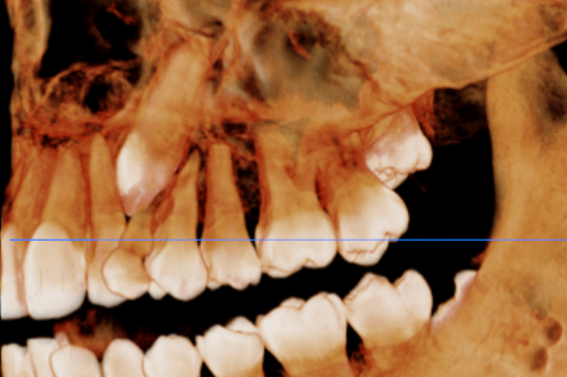
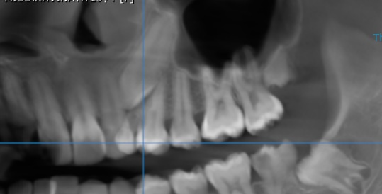
3-DIMENSIONAL VIEW
CROSS- SECTIONAL IMAGES
23 REGION | 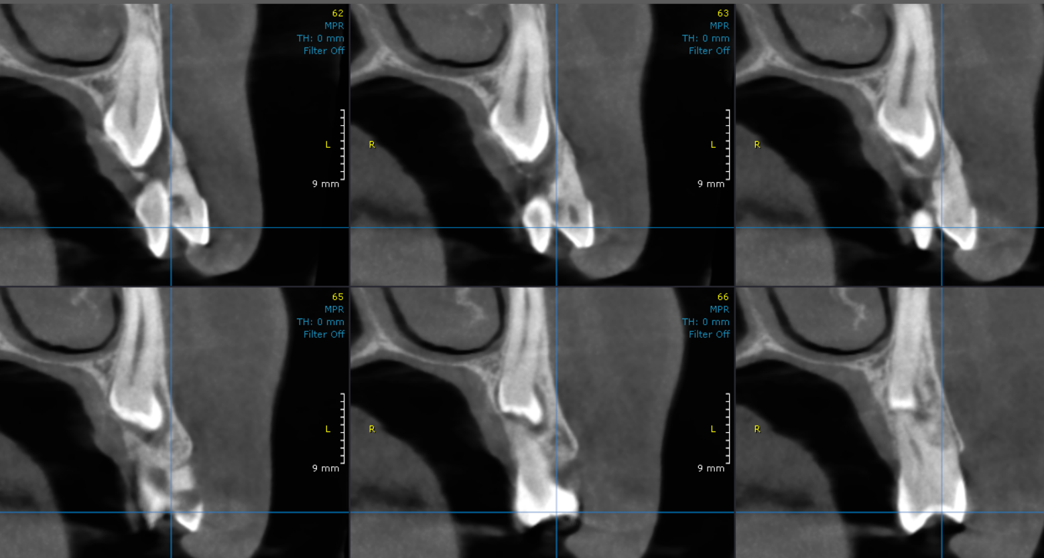

**** End of report ****

